Chapter 10, Solution 14.

At node 1,
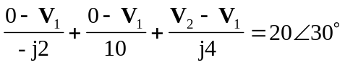
(1)

At node 2,
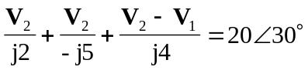
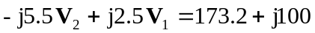 (2)

Equations (1) and (2) can be cast into matrix form as
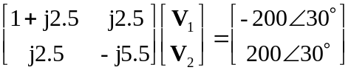

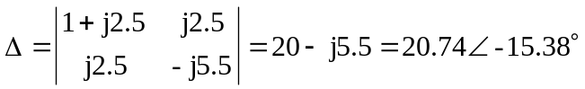

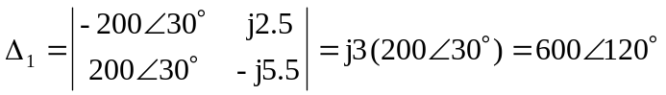
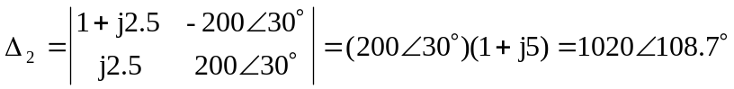

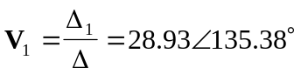V
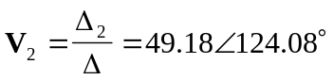V

